Hi Laura and Jing.

The attached document is a list of questions and issues that we have with Metacat. I am sending it to compile in only one document all them and you evaluate if you can give us support.

- Data: The first set of data that we want to put on the server are our meteorological records. We have 45 excel files that contain the data of our meteorological stations located each field station. Carolina added the firs record and I doing a couple of steps generate four more records for the same meteorological station but with data of different years. Now we have five records on https://metacat.ots.ac.cr/metacatui/#data/page/0 with a generic user for OTS (dataone_ots). The support that I need from you is that look the five records and tell us if you think that are ok.

- Why the packages that we have in our server are not in?

- I can see our records on http://metacat.ots.ac.cr
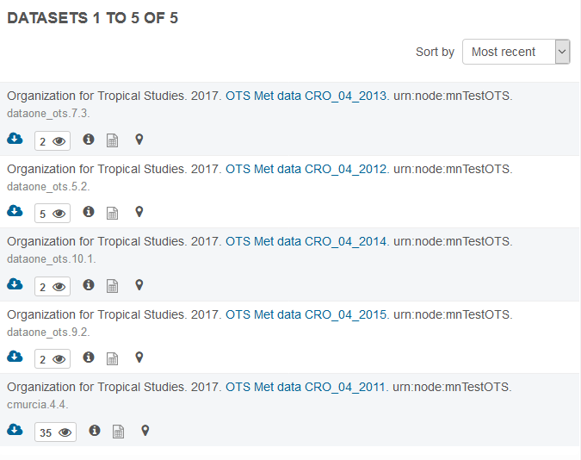

When I press the blue cloud to download I get this message:

Not Found

The requested URL /metacat/d1/mn/v2/packages/application/bagit-097/resourceMap_cmurcia.4.4 was not found on this server.
Apache/2.4.10 (Debian) Server at metacat.ots.ac.cr Port 443

The map show me this sentence:
Oops! Something went wrong.
This page didn't load Google Maps correctly. See the JavaScript console for technical details.

- If I go inside of any record:

If I press the link of the user that post the data, nothing is happing.

If I press download I get this message:
This XML file does not appear to have any style information associated with it. The document tree is shown below.
<error detailCode="0000" errorCode="400" name="InvalidRequest"><description>No resource matched for package/cmurcia.4.4</description></error>

- Why the format of https://search.dataone.org/#data it is very diferent to https://metacat.ots.ac.cr/metacatui/#data/page/0?

- We have another important data. It is the data about our plants inventory. We have two on-line databases that use relational structures and where we cannot generate plain outputs because it manage a big amount of records including images and many tables. Do you have an example that how people managing this kind of data generate metadata for their data?.

